**At St. Xavier’s College, a Faculty has the following data in My SQL in database named as Class having**

table student related to Semester Examination

Enrollment No. Student Name Section Subject Id Marks

1 Tim A 1 70

2 Jim A 2 75

3 Kim B 3 65

4 Tom B 4 77

5 John C 5 60

6 Joe C 1 82

7 James B 2 76

8 Henry C 5 68

9 Matt B 3 71

10 Paul A 4 79

The Faculty needs a section-wise Number of candidates who have secured more than or equal to 75

marks in the Semester Exam.

Note: Enrollment No. is declared as Primary Key

# We need to create a table like this on our database so create a database(my db is task1 given)



# then create a table and insert all values (i created te table name college)

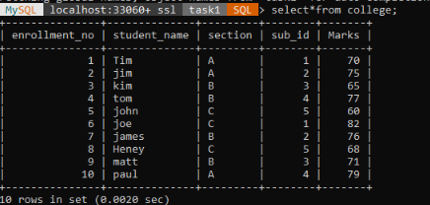

# after view the table

# execute the query

select section,count(section) as 'No of candidates reater ten or equal to 75 marks' from college group by section;

